Be an Artist for a Week
For Children aged 5 years to 14 years.
2nd July – 27th July 2018
At Tearmann Artist Studios
Castlekeeran, Carnaross, Kells, Co. Meath. Time: 10.00am. – 2.00pm 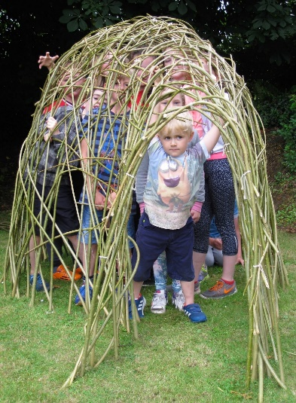 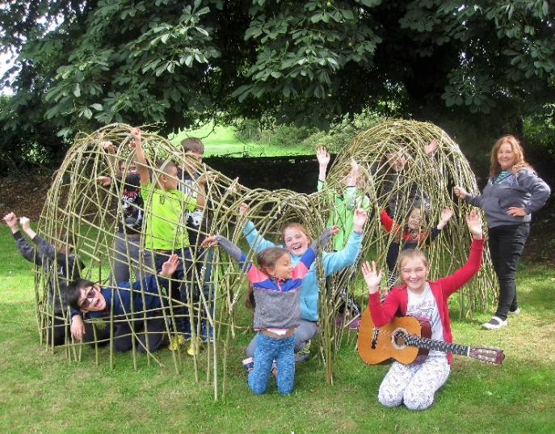 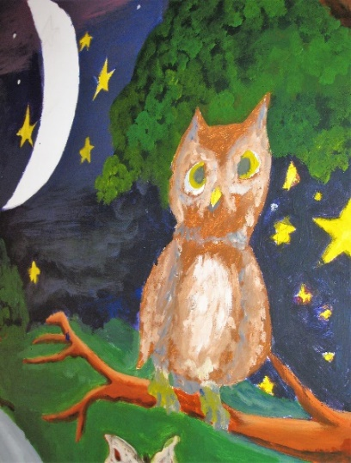
Set in idyllic settings near St. Kiernan’s Well, in the hearth of North Meath, just 3 miles from Kells, and 1 mile from Carnaross. Just off N3.and M3
Come and discover your creative self in a fun-loving way with professional Artists Beth Newman Maguire, Jacqueline Keane and assistant Mary Curtis.
Activities: Drawing, Painting, Sculpture, Printing, Clay Modeling, Plaster Casting, Willow Weaving, Photography, Painting a Mural, Fun and Games, Nature Trail and much more.
Children to bring a packed lunch each day and picnic in the gardens at Tearmann. Cost per week €100 = 1st child/ 2nd child = €85/ and 3rd = €70
Tel: 086 8368936 or emailnewmanartist@gmail.com www.bettynewmanmaguire.ie

2nd July– 6th July | 9th July– 13th July | 16th July – 20st July | 23th July– 27th July
Please tick preference

Students Name_______________________________ Age: __________ Tel No. _____________
Address_______________________________________________________________________________
Deposit €20._________ Balance Due.___________ Parents Signature. _________________________
Tutors are Garda Vetted and Qualified with MFA, BA Degrees in Art & Design and experience of working with children and adults

