Having trouble deciding on which Art College you would like to apply to and not knowing how to prepare a portfolio? Help is here.
Art Portfolio Preparation Course
3 ½ weeks course from ^{6th} June – 30st Jun. 10.00am – 3.00pm daily.
TEARMANN ARTIST STUDIOS
Castlekeeran, Carnaross, Kells, Co. Meath
This course is especially suitable for 5th and 6th year Secondary School students and mature students who are considering pursuing a career in Art in 2018 / 2019 and 2020. The course is developed and delivered by Beth Newman Maguire who has 20 years’ experience in portfolio preparation for entry to Art Colleges in Ireland and abroad. Assisted by another Art Teacher who has experience in Portfolio Preparation.
Activities covered will include:
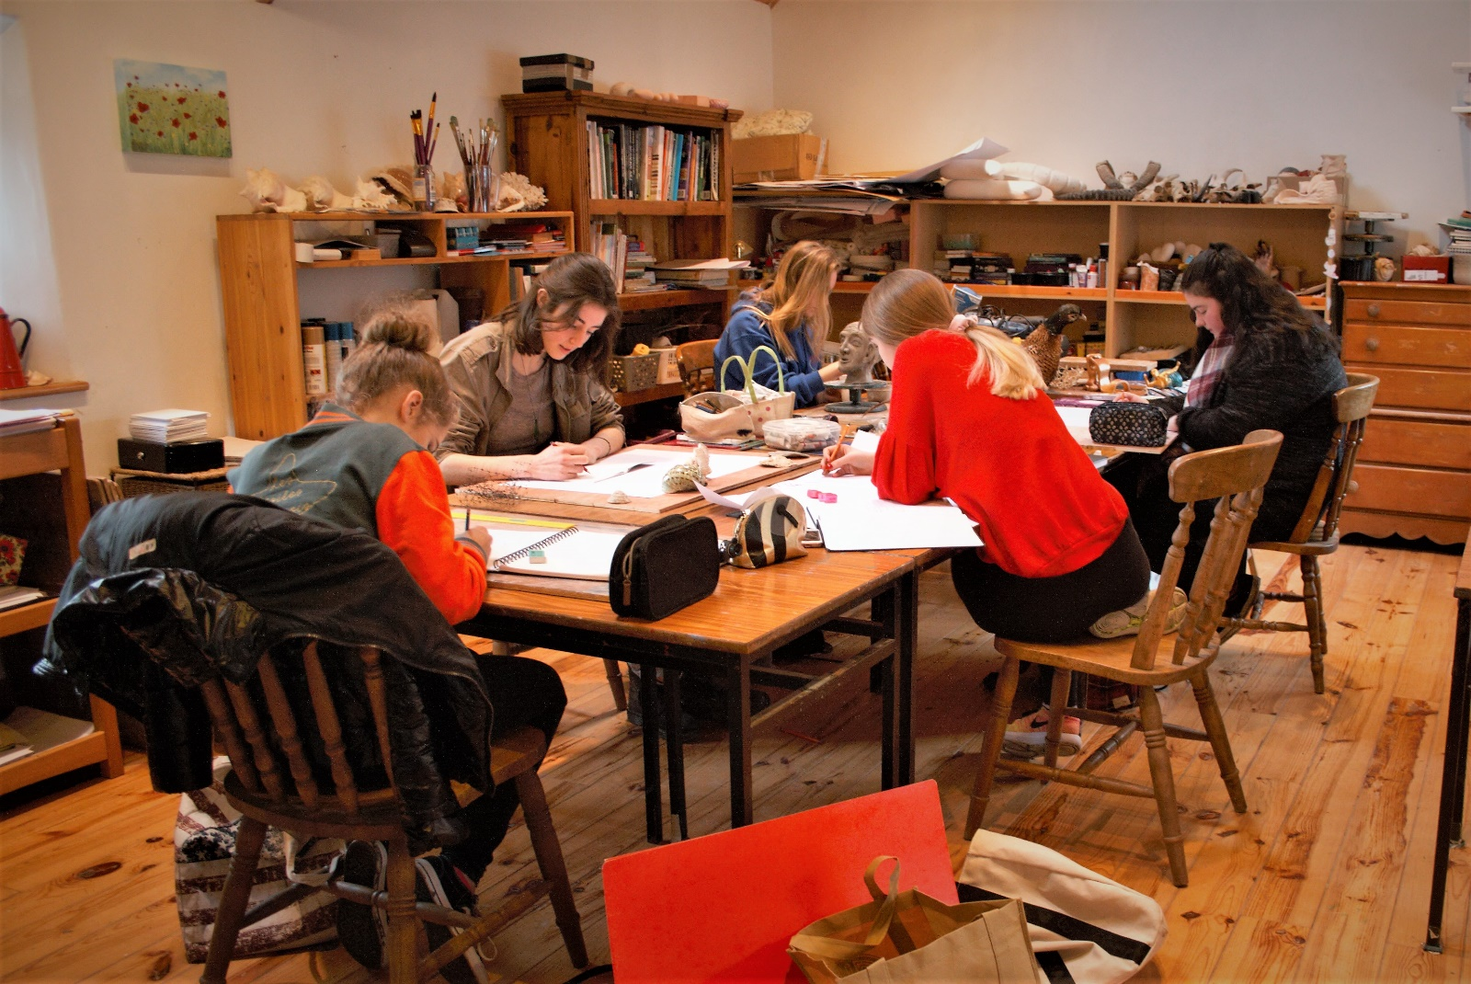
What is a Portfolio?
How to prepare a Portfolio?
How to develop a theme?
NCAD Brief.
Examples of successful Portfolios,
College Application requirements, dates etc.
Evaluation of your work to-date.
Advice on which College to apply for.
Opportunities available to graduates.

Cost: €200 per week. Course limited to 10 students. All art materials supplied.
Deposit of €50 needed to secure your place when booking.
For further information contact
Artist Beth Newman-Maguire at “Tearmann Artist Studio” Castlekeernan, Carnaross, Kells, Co. Meath. 046 9245915. Mobile 086 8368936. Email. newmanartist@gmail.com www.bettynewmanmaguire.ie

